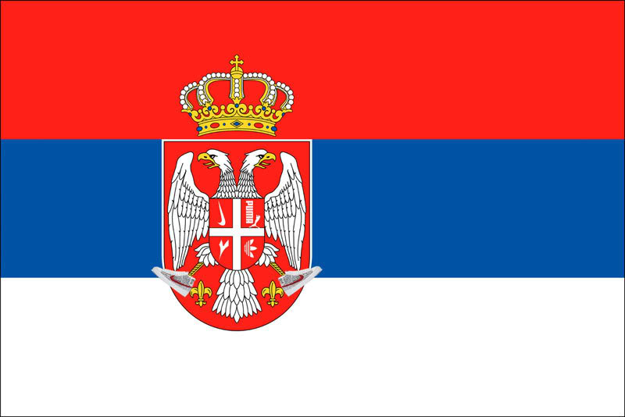 Parlez Vous QSO ?! – Srpskog / Serbian v 1.0

Ref. | Category / Phrase | Translation
1.0 | Opening Greetings | Pozdrav na pocetku veze
1.1 | I am very pleased to meet you. | Drago mi je da se upoznajemo
1.2 | Thank you for your call | Hvala na pozivu
1.3 | Good morning | Dobro jutro
1.31 | Good day | Dobar dan
1.32 | Good afternoon | Dobro popodne
1.33 | Good evening | Dobro vece
1.4 | I know only a little Serbian but I enjoy QSOs in Serbian. | Znam samo malo srpskog, ali volim da radim veze na srpskom jeziku
2.0 | Operator | Operator
2.1 | My name is Marko. | Moje ime je Marko.
2.2 | I have been licensed since 2005. | Posedujem licencu od 2005.
2.3 | I have been licensed for 5 years. | Licenciran sam vec pet godina.
2.4 | I live in Sittingbourne. | Zivim u Sitingburnu.
2.5 | Sittingbourne is a village. | Sitinburg je selo.
2.51 | Sittingbourne is a town. | Sitinburg je gradic.
2.52 | Sittingbourne is a city. | Sitinburg je grad.
2.6 | Sittingbourne is between London and Dover. | Sitinburg se nalazi izmedju Londona i Dovera.
2.7 | I live in the South of England. | Zivim na jugu Engleske.
2.71 | I live in the North of England. | Zivim na severu Engleske
2.72 | I live in the East of England. | Zivim na istoku Engleske
2.73 | I live in West of England. | Zivim na zapadu Engleske
2.74 | I live in South East England. | Zivim na jugoistoku Engleske
2.75 | I live in South West England. | Zivim na jugozapadu Engleske
2.76 | I live in North East England. | Zivim na severoistoku Engleske
2.77 | I live in North West England. | Zivim na severozapadu Engleske
2.78 | I live in central England. | Zivim u centralnoj Engleskoj
2.8 | I live in the country. | Zivim na kopnu
2.81 | I live by the sea. | Zivim pored mora
2.82 | I live near mountains. | Zivim u planinskom delu
2.9 | Sittingbourne is 50Km from London. | Sitinburg je 50Km od Londona
2.11 | I am retired. | U penziji sam
2.12 | My home call sign is M0ECS. | Moj domaci pozivni znak je M0ECS
3.0 | Station | Stanica
3.1 | My radio is an Icom 706. | Moj primopredajnik je Icom 706
3.2 | My station is all homebrew (homemade). | Moj primopredajnik je kucne izrade
3.3 | I am running 5 Watts. | Radim sa 5W snage
3.4 | My antenna is a long wire. | Moja antena je long wire
3.41 | My antenna is a dipole. | Moja antena je dipol
3.42 | My antenna is a G5RV. | Moja antena je G5RV
3.43 | My antenna is a doublet. | Moja antena je dublet
3.44 | My antenna is a delta loop. | Moja antena je delat lup
3.45 | My antenna is a vertical. | Moja antena je vertikalka
3.46 | My antenna is a log periodic. | Moja antena je log periodik
3.47 | My antenna is a Yagi beam. | Moja antena je Yagi bim
3.48 | My antenna is a 5 element beam. | Moja antena je petoelementni bim
4.0 | Conditions | Uslovi
4.1 | Thank you for my 599 report. | Hvala za 599 raport
4.2 | The band conditions are good. | Uslovi na bandu su dobri
4.3 | The band conditions are bad. | Uslovi na bandu su losi
4.4 | There is strong interference here. | Imam jaku inteferenciju ovde
4.5 | Can you change to the 80m band? | Da li mozes da se prebacis na 80m band?
4.6 | Please change frequency to 3.558 MHz. | Molim te, promeni frekvenciju na 3.558 MHz
5.0 | General Queries and Comments | Opste informacije i komentari
5.1 | What does <#####> mean please? | Sta znaci <####>?
5.2 | Please wait a moment, I need to check my Serbian dictionary. | Molim te sacekaj, moram da proverim moj recnik Srpskog.
5.3 | How do you say, <#####> in Serbian ? | Kako se kaze <#####> na Srpskom?
5.5 | My favourite modes of operation are CW / RTTY / PSK / MT63 / Olivia / Hellschreiber / Digital Modes / and SSB | Moji omiljeni modovi rada su CW / RTTY / PSK / MT63 / Olivia / MT63 / Digitalni mod i SSB.
5.6 | My best DX is Australia. | Moja najbolji DX je Australija.
5.7 | I enjoy working contests. | Uzivam da radim takmicenja.
5.8 | I like working QRP. | Volim da radim QRP.
6.0 | The Weather | Vremenski uslovi
6.1 | It is sunny. | Suncano je.
6.2 | It is windy. | Vetrovito je
6.3 | It is raining. | Pada kisa
6.4 | It is snowing. | Pada sneg
6.5 | It is very hot. | Veoma je vruce
6.6 | It is very cold. | Veoma je hladno
6.7 | The temperature is 8C. | Temeperatura je 8 stepeni (C)
6.8 | It is overcast. | Oblacno je
6.9 | It is foggy. | Maglovito je
6.11 | It has been raining all day. | Pada kisa celog dana
6.12 | There is 20cm of snow here. | Palo je 20 centimetara snega
8.0 | QSL | QSL
8.1 | My QSL card is sure via the bureau. | Moja QSL karta sigurno stize preko biroa
8.2 | QSL via eQSL | QSL preko e-QSL.
8.3 | No eQSL please | Ne primam eQSL.
8.4 | I will send you my card direct. | Poslacu ti QSL direktno.
8.5 | What is your address? | Koja je tvoja adresa
8.6 | Please send your QSL card direct. | Molim te, posalji tvoju QSL direktno
8.7 | My address is... | Moja adresa je ….
8.8 | My address is shown on QSL.com / EHam.net / ….. | Moja adresa je prikazana na: qsl.com / EHam.net / .....
8.9 | Sorry I do not send QSL cards. | Zao mi je, ne saljem QSL.
8.11 | Please send QSL card via G1JQH. | Posalji QSL preko G1JQH.
8.12 | My WACRAL / GQRP / DXCC / FISTS number is 1234. | Moj WACRAL / GQRP / DXCC / FISTS e’ broj je 1234.
9.0 | Final Greetings | Pozdravi
9.1 | Thank you. | Hvala
9.2 | Thank you for a very enjoyable contact. | Hvala na veoma prijatnom kontaktu
9.3 | I enjoyed our chat. | Uzivao sam u nasem razgovoru
9.4 | I enjoyed our QSO in Serbian. | Uzivao sam u nasem QSO na Srpskom.
9.5 | It has been great fun. | Mi sono divertito molto.
9.6 | If you would like a regular contact with me, you can contact me via email. | Ako zelis drugi kontakt samnom, mozes me kontaktirati na e-mail.
9.7 | My email address is... | Moja e-mail adresa je...
9.8 | My email address is shown on QSL.com / EHam.net | Moja e-mail adresa je prikazana na qsl.com / EHam.net.
9.9 | I look forward to meeting you again. | Unapred se radujem ponovnom susretu
9.11 | My best wishes to you and your family. | Sve najbolje tebi i tvojoj porodici
9.12 | Best wishes to your wife. | Sve najbolje tvojoj supruzi
9.121 | Best wishes to your husband. | Sve najbolje tvom suprugu
9.13 | Good luck. | Srecno.
9.14 | Good health. | Dobro zdravlje
9.15 | Goodbye | Dovidjenja
9.16 | I wish you an enjoyable afternoon. | Zelim ti prijatno popodne
9.161 | I wish you an enjoyable evening. | Zelim ti prijatno vece
9.162 | I wish you an enjoyable weekend. | Zelim ti prijatan vikend
9.17 | Enjoy your holiday. | Uzivaj u praznicima
9.18 | Happy New Year. | Srena Nova Godina
10.0 | Country | Drzave
10.1 | Albania | Albanija
10.2 | Austria | Austrija
10.3 | Belgium | Belgija
10.4 | Belorussia | Belorusija
10.5 | Bosnia & Herzegovina | Bosna i Hercegovina
10.6 | Bulgaria | Bugarska
10.7 | Croatia | Hrvatska
10.8 | Czech Republic | Ceska Republika
10.9 | Denmark | Danska
10.11 | Eire | Irska
10.12 | England | Engleska
10.13 | Estonia | Estonija
10.14 | Finland | Finska
10.15 | France | Francuska
10.16 | Germany | Nemacka
10.17 | Gibraltar | Gibraltar
10.18 | Greece | Grcka
10.19 | Holland | Holandija
10.21 | Hungary | Madjarska
10.22 | Iceland | Island
10.23 | Northern Ireland | Severna Irska
10.24 | Isle of Man | Ostrvo Man
10.25 | Italy | Italija
10.26 | Latvia | Letonija
10.27 | Liechtenstein | Linhestajn
10.28 | Lithuania | Litvanija
10.29 | Luxembourg | Luksemburg
10.31 | Macedonia | Makedonija
10.32 | Moldavia | Moldavija
10.33 | Netherlands | Holandija
10.34 | Norway | Norveska
10.35 | Poland | Poljska
10.36 | Portugal | Portugal
10.37 | Romania | Rumunija
10.38 | Russian Federation | Rusija
10.39 | Scotland | Skotska
10.41 | Slovakia | Slovacka
10.42 | Slovenia | Slovenija
10.43 | Spain | Spanija
10.44 | Svalbard | Svalbard
10.45 | Sweden | Svedska
10.46 | Switzerland | Svajcarska
10.47 | Turkey | Turska
10.48 | Ukraine | Ukrajina
10.49 | Wales | Vels

Credits: Marko Milenkovic, YT8CDC

